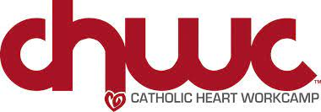

To attend the Catholic Heart Workcamp, June 19-25, 2022, please complete the following registration form and return it with your $100 deposit.

First Name: ______________________________________ Last Name: ______________________________
Student email: __________________________________ Student Cell #: _____________________________
Grade (21-22) _____________________ Age: ____________________ Shirt Size:_____________________
Parent(s) Name: ___________________________________________________________________________
Home Address: ____________________________________________________________________________
City: ________________________________________ State: _________________ Zip: _________________
Parents Cell #s: Mother: _________________________________ Father’s ___________________________
Parents Email: Mother: __________________________________ Father: ____________________________

Camp Cost: $435 + additional fees if extra activity is added.
Deposit: $100. Due at registration.

We will offer opportunities for fundraising.

I promise to be an example of Christ's love before, during and after our trip. I am committed to making this trip the very best it can be through my time, talent and treasure. I will abide by all expectations and rules before, during and after camp, especially avoiding those things that may harm me, my friends and my family. I fully understand that where we go to serve is not as important as the actual service itself, and will serve those in need with joy and thanksgiving for the Gospel message Jesus Christ.

Signature of Participant: _________________________________________________ Date: ___________

Signature of Parent: _____________________________________________________ Date: __________

Payment Amt: __________________________ Check #_______________ Cash Online

